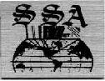



P.U.T Acoustic Image Viewer
User’s Guide

Version 1.1

1384-2005

Table of Contents

Executing the Program 2
Program Images 2
Open an Amplitude File 2
Open a Radius File 3
Filters 4
Trim Filter 4
Low-Pass Filter 5
Kalman Filter 6
Gaussian Filter 7
AntiAliasing Filter 8
Save Images 9
Exit 9

Executing the Program
We execute the drive program by clicking on its icon on the desktop. The splash screen of the package would be shown and the program is run.

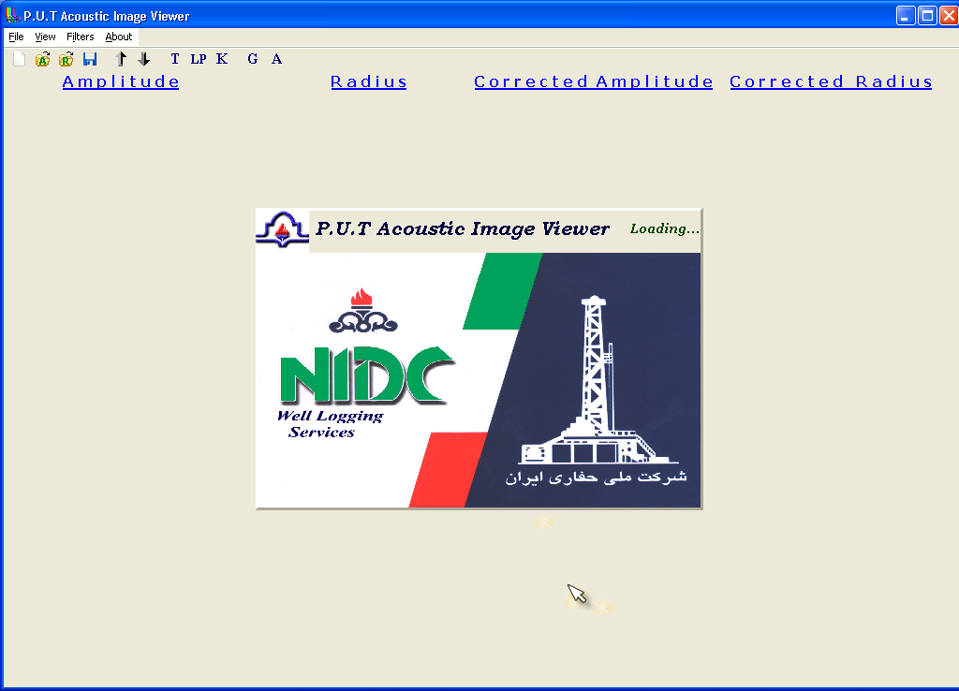

Program Images
The program consists of four images which are original and corrected amplitude and radius images.

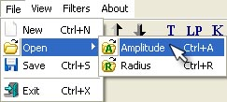
Open an Amplitude File
To open an amplitude data file click File/Open/Amplitude or press Ctrl+O. Data file has to be of LAS kind so that the program could open it.

Select a LAS file and click on Open button. File data are converted to image.
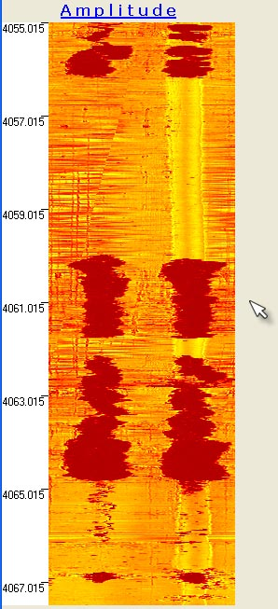
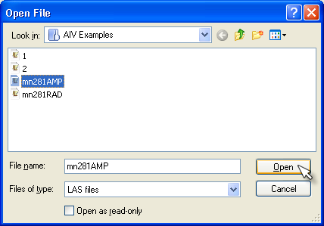

Open a Radius File
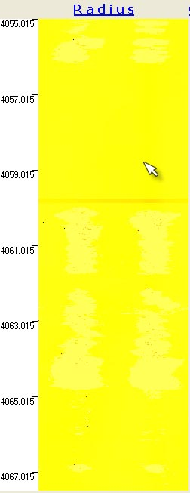
To open a radius data file click File/Open/Radius or press Ctrl+R. Same as amplitude file, radius file has to be of LAS kind so that the program could open it.
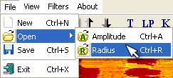
Select a LAS file and click on Open button. File data are converted to image.

Filters

Trim Filter
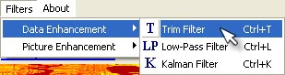
To apply trim filter on data, click Filters/Data Enhancement/Trim Filter or press Ctrl+T.

Trim filter settings window would open.
Now, we can change maximum and minimum values which are used for calculation of color range of the image.
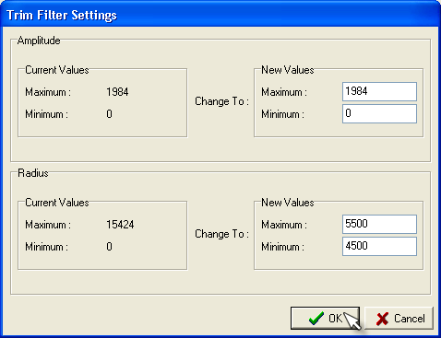

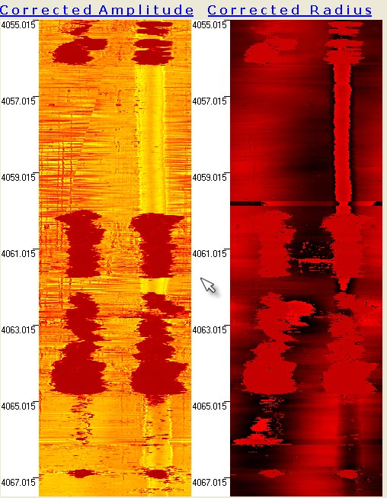

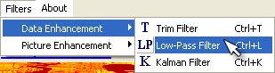
Low-Pass Filter
To apply low-pass filter on data click Filters/Data Enhancement/ Low-Pass Filter or press Ctrl+L.

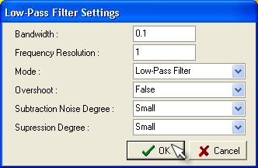
Low-pass filter settings window would open. Press Ok to apply the filter with the default options.

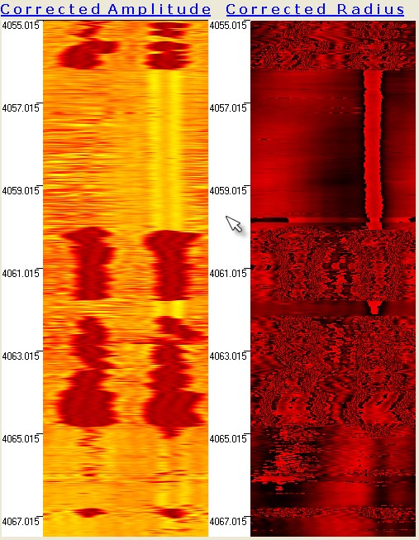

Kalman Filter
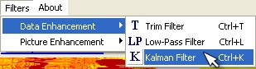
To apply Kalman filter click Filters/Data Enhancement/Kalman Filter or press Ctrl+K.

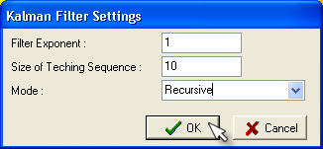
Kalman filter settings window would open. Press Ok to apply filter with the default options.

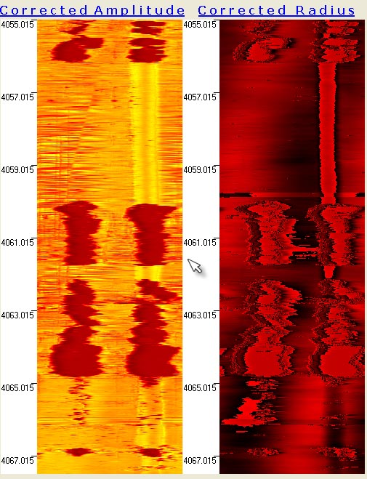

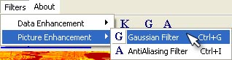
Gaussian Filter
To apply Gaussian filter on the images click Filters/Picture Enhancement/Gaussian Filter or press Ctrl+G.

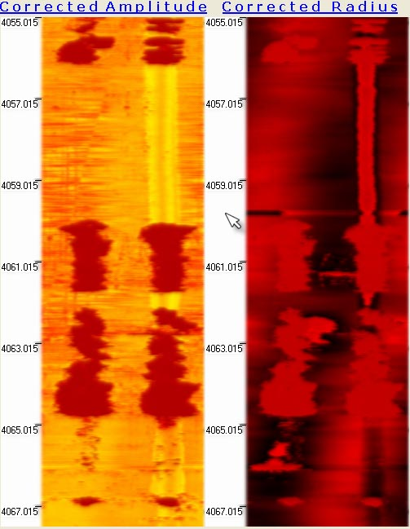

AntiAliasing Filter
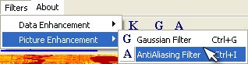
To apply AntiAliasing filter on the images click Filters/Picture Enhancement/ AntiAliasing Filter or press Ctrl+A.

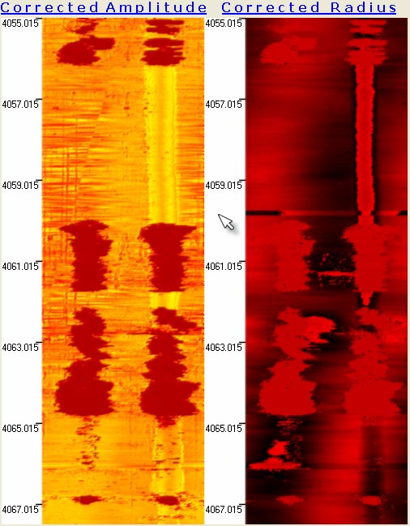

View
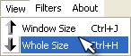
To see all parts of the images, click View/Whole Size or press Ctrl+H. To get back to the window size, click View/Window Size or press Ctrl+J.

Save Images
To save four images as bitmap files, select File/Save or press Ctrl+S. Save dialog box would open. Type desired names for images and click on the Save button.
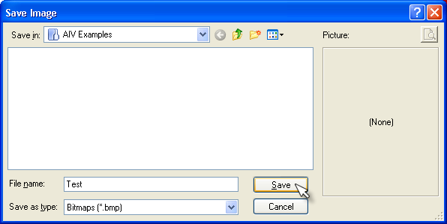

Exit
To exit the program package, click File/Exit or press Ctrl+X.

